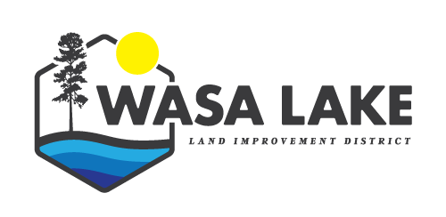
WASA LAKE LAND IMPROVEMENT DISTRICT
AGENDA FOR TRUSTEES
For Meeting at 7 PM, June 29, 2022
WLLID OFFICE
Topic | Items
Call to Order
In Attendance
Adoption of Agenda
Adoption of Minutes of previous meeting
Introduction of Late Items
- Trustee Volunteer time
2. Taxes | 1. 2022 Tax Notices  2. Land Titles
3. Communication outgoing | 1. Buzz  2. Newsletter  3. Kiosk  4. Website
4. Water | 1. Water  2. June 1 & 15 water level update  3. Interior Health beach sampling  4. BCLSS Secchi Dip-In  5. Water Licence Fishgate  6. If we get high water
Follow up on action Items
Petitions and delegations
Correspondence
Financials | Financial Overview –  1,Monthly bank total report
Reports
Bylaws
Resolutions
New Business | 1.Board Development Session  2.External Hard Drive for backup
Question Period
Adjournment

