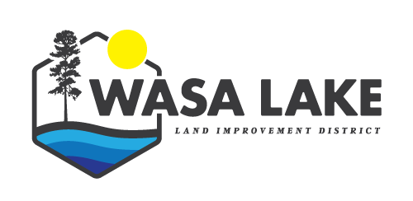
WASA LAKE LAND IMPROVEMENT DISTRICT
AGENDA FOR TRUSTEES
For Meeting after AGM, October 5, 2022
WLLID OFFICE

Topic | Notes | Action
Call to Order | Sharon called meeting to order at 7:14 p.m.
In Attendance | Sharon Prinz  Nowell Berg  Tom Braumandl  Lori Vandette (CO) | Quorum is 3
Adoption of Agenda | Move that agenda be adopted by Nowell Berg  Seconded by Tom Braumandl  Carried
Adoption of Minutes of previous meeting | Move to adopt minutes of August 31, 2022 by Tom Braumandl  Seconded by Nowell Berg  Carried
Introduction of Late Items | N/A | Must be introduced & info pertaining to late items must be distributed to board members ahead of time, otherwise it cannot be added to agenda
Business Arising from the minutes and unfinished business;
- Trustee Volunteer time | Tom – one hour since Aug. 31
2. Election of Chair | Sharon Prinz unanimously voted to continue as Chair | Depending on Oct. 15th RDEK election results, Nowell Berg may take over the Chair position for the year.
3. Correspondence | BC Hydro street lights - | Street lights do not fall under the WLLID mandate, which is to maintain a good quality and quantity of water in Wasa Lake, and so the issue has been turned over to the RDEK. Street lights are located at each entrance to Wasa and were put in place for safety. Jane Walters stated covering the cost of replacing them would have to go to a referendum (which could take up to 8 yrs), so in the interim, the cost could be covered by a discretionary grant in aid.
4. Financials | 1.Monthly bank total report  Move to pay the bills by Nowell Berg, seconded by Tom Braumandl  2.Community Bond - | One bill to pay from Big Magic Design for final panel in new kiosk.  Community Bond ($15,000) has come up for renewal. Decided we would continue for a non-redeemable 12 month term at 4%  Motion made to remove Phil Godsave & Becky Knight from the EKC banking access and add Tom Braumandl and Lori Vandette. Moved by Nowell Berg and seconded by Sharon Prinz.
5. Communication | Buzz & Newsletter for November due October 15th | *Sharon Prinz will do up a draft to be passed on to Nowell Berg for additions before being submitted.-  *There was extended discussion on the future of WLLID – we face challenges of getting volunteers stepping forward for Trustee positions. This will be an ongoing discussion as possibilities are brought forward and/or eliminated. There may be Town Hall Meetings scheduled in the future to get as much community involvement / input as possible before any final decisions are made.  *Living Lakes has lost funding for a foreshore survey (approx.$60,000) to assess any damage incurred by boats. It was suggested we look into covering some of the cost, with the balance paid through CBT grants. Sharon will speak to Caitlyn. We also need an new aerial study (approx.. $4-6,000) done (April 2023?) and another Bathymetric study should also be looked at (cost unknown).  *Tom Braumandl will continue to look into the rehab/demo permitting and procedures.  *We still need a letter from RDEK confirming we no longer are responsible for mosquito control.
6. Date of Next Meeting | November 2nd @ 7 p.m.
Adjournment | Move to adjourn by Nowell Berg, seconded by Tom Braumandl

