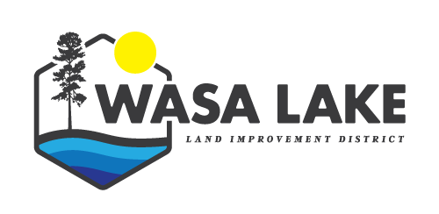
WASA LAKE LAND IMPROVEMENT DISTRICT
AGENDA
For Meeting at 7 PM, July 17, 2023
Topic
Call to Order | Sharon called the mtg to order at
In Attendance | Sharon, Nowell, Lori
Addition of Late Items | none
Adoption of Agenda | Motion to adopt July agenda
Adoption of Minutes | Motion to adopt May 10th minutes and June 15th minutes
Correspondence | Decision on pamphlet to inform taxpayers of options if there are no trustees to fill available positions after the September AGM  Replied to residents RE: tax penalties, etc. Sent them a letter outlining why penalties are applied etc. Copy of letter available for review. This will be included with all future tax invoices.  Sharon replied to Jocelin’s concerns about the algae
Financial Reports:  Aged overdue receivables:  $5006.15 | Tax payments slowly trickling in. Some have paid their arrears in full, some refuse. Planning on sending out statement reminders by the end of June.
- Land Title Transfers - | 6:  6290 Ash Rd  Change of ownership percentage  Change of ownership percentage  Change of ownership percentage?  Boyle sold to: Malyszko  Change of ownership percentage?
2. Communication | Mapping approved for Wasa Lake by Selkirk Innovates
3. Financials -  Bank balance: $25,935.93  Capital Reserve: $8,196.36  current interest rate = 0.450%  Contingency Fund: $10,228.60  current interest rate = 1.350%  12M Bond: $15,097.50  interest rate = 4%  18M Bond: $10,399.83  interest rate = 2.5% | Waiting on Financials from Toni Lepore – no response to Sharon’s physical visit or my emails.  Kootenay Computer invoice for $70.56  Payment required to WCB for $253.98  Hub Insurance $738.00  Lori’s invoice, which includes the monthly Weebly payments totaling $30.00 (July)  Motion by, seconded by, all in favour  Invoices approved.
4. New Policies/Bylaws | n/a
5. Items discussed at last mtg | Nowell received a quote from Lotic RE: sediment and water testing
New Business
Date of Next Meeting: | Aug 9?
Adjournment | move to adjourn by, second.

