As part of its mandate to monitor the quantity and quality of water at Wasa Lake, WLLID volunteers undertake hundreds of hours measuring and sampling water.
From mid-May to early October, WLLID volunteers use several different measures to gauge the status of lake water, and any changes with it. Ice-on and ice-off dates are also recorded.
WLLID takes daily depth readings at the lake and Kootenay River. These values are entered into a database where changes in water level are recorded and graphed. Reports on water levels are posted on the WLLID website (wasalake.ca). WLLID statistical analysis on historical water levels at Wasa shows that 86% of the variability in the water level is accounted for by the amount of snow measured with the snow pillow at Floe Lake. (https://www.nwrfc.noaa.gov/snow/snowplot.cgi?FLKQ2)
On April 14th, the snow water equivalent at Floe Lake was 81% of normal for this time of year. Last year at this time, the snow pillow had an additional 10 inches of snow water equivalent. As freshet progresses, rising water levels are used to calculate an estimate of the expected peak water level.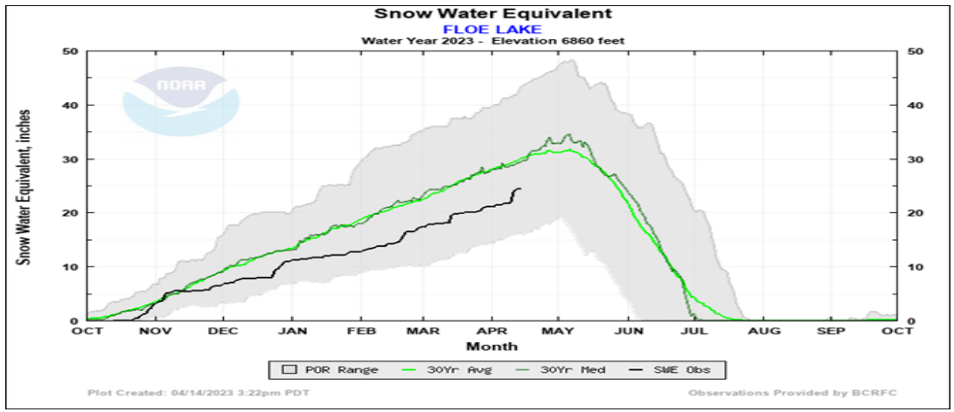
WLLID releases this estimate on June 1st. It is posted on the WLLID website.
A number of parameters are used to gauge the quality of water, which has a direct impact on aquatic life, water fowl, and people using the lake.
Starting in mid-June, WLLID volunteers take weekly measurements of dissolved oxygen (DO) and temperatures at one meter intervals from the surface to the bottom at a location in the SE portion of the lake known as Deep Station. Secchi readings, used to determine water transparency, are also taken at the same time. Data recording sheets are filled out and a spreadsheet contains all readings.
Before and after each summer long-weekend (July, August, September), WLLID volunteers collect water samples from six public beaches. These samples are sent to Interior Health (IH) for E. coli testing. Results are posted on the IH website: https://services.interiorhealth.ca/publichealthprotection/watersamples.aspx
At the end of the water monitoring season, WLLID volunteers upload the yearly data to the Columbia Basin WaterHub (https://data.cbwaterhub.ca/). Historic and current water data is housed there so that any person with an interest in water at Wasa can view and graph water level changes going back to 1996.
The Wasa Lake Land Improvement District (WLLID) is mandated to monitor the quantity and quality of water at Wasa. To slow Kootenay River water flow into Wasa Lake during floods two trial mitigation flapgate culverts were installed by the WLLID over 30 years ago. Back in the day Kootenay River water flowing by Wasa was laden with pollutants from the pulp mill and so the thought of this water entering the lake was troubling. With modern pollution control on pulp mill effluent the water quality is much better, but we would still like to slow the inflow of river water in a flood.
The project was designed to prevent Kootenay River water flowing into Wasa Lake by:
• replacing the old highway waterbar (dip in the road surface) on the south end of Cameron Pond with a flapgate culvert as a trial flood mitigation control for water from the south,
• installing a flapgate where Hansen channel flows under Highway 95 to mitigate water from the west
During high water, as seen in the past few years, river water rises pushing water into the sloughs and closing the flapgate on the south of Cameron Pond. This results in slowing water flow northwards into Wasa but groundwater will still cause the lake to rise. As well, Lewis Creek water may enter Wasa Lake from the south due to the closed flap gate not allowing Lewis Creek to drain into the slough.
Recently, some muskrats, beavers, or otters decided that they would like Cameron Pond to be a little deeper and so attempted to plug the entrance to the flap gate with debris.
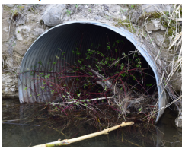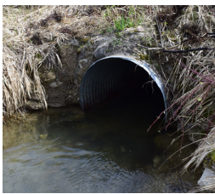
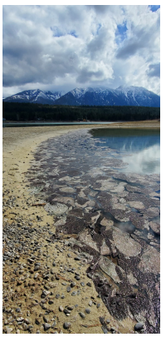
On May 5th, a WLLID trustee cleaned out the debris and restored the flow of water through the culvert. Photos show the debris plugging the culvert and dramatically reduced water flow. After the clean out water flow returns to normal.
There was an algae bloom on Ida’s bay covering about 250 sq. meters of lake that was discovered in late April. It turns out that it was a non-toxic variety (a type of green filamentous algae). These blooms occur when nutrient levels increase along with temperatures in the presence of calm water. Although it may have been nontoxic had it spread it would have been extremely unpleasant for lake users. WLLID organized some folks and we removed about 10 wheelbarrows full of the algae. We will continue to monitor to make sure this isn’t a recurring problem.
WLLID also organized a road side cleanup of Wasa Lake Park Drive in May. It seems that trash volumes are down from previous years. Enjoy the cleaner roadside and let’s keep it that way.
You have seen the articles in the Buzz about Volunteers and their declining numbers. The Land Improvement District is no different than the other organizations in our community. We run on elected Volunteers. We have not been able to fill one of our Trustee positions and it is sometimes difficult to have a quorum. In the fall we will be losing at least one trustee and have no indication that we will have a full slate of trustees running for election.
Looking to the future we are exploring options that may be open to the board and the community. Maybe there is a better way to be inclusive of the residents and their input in regards to the Quality and Quantity of the water in Wasa Lake. Is this the right format? Some of the alternatives might be starting a lake stewardship group so that more participation from part-time residents can be encouraged and having the mandate of the WLLID transfer to regional or provincial government. Alternatively, we might be able to interest a non-profit organization in taking over the maintenance of the trial flood mitigation gates at Cameron Pond or getting some young energized folks on or assisting the WLLID board. These alternatives all have tax implications. We will keep the community apprised of the information as we progress through this information gathering.
We have approached Ducks Unlimited, the Nature Trust of BC, and the Provincial government to see if they might take over maintaining the flood mitigation gates on Cameron Pond. Unfortunately, none of them are interested. We are still hopeful local residents will come forward to help keep WLLID functioning but barring that we will keep you posted on how having the RDEK take over from us may affect you.
If you have an interest in becoming a trustee or assisting with the summer water monitoring, please contact admin@wasalake.ca.

